1. Create an m-file, named “example9p3p3_LastName.m”, that has all the MATLAB®

statements listed in section 9.3.3 of the textbook (page 218). However, modify it so

that the markers of the decaying function are squares instead of circles and set the

line width of the other sinusoid to 2 instead of 4.

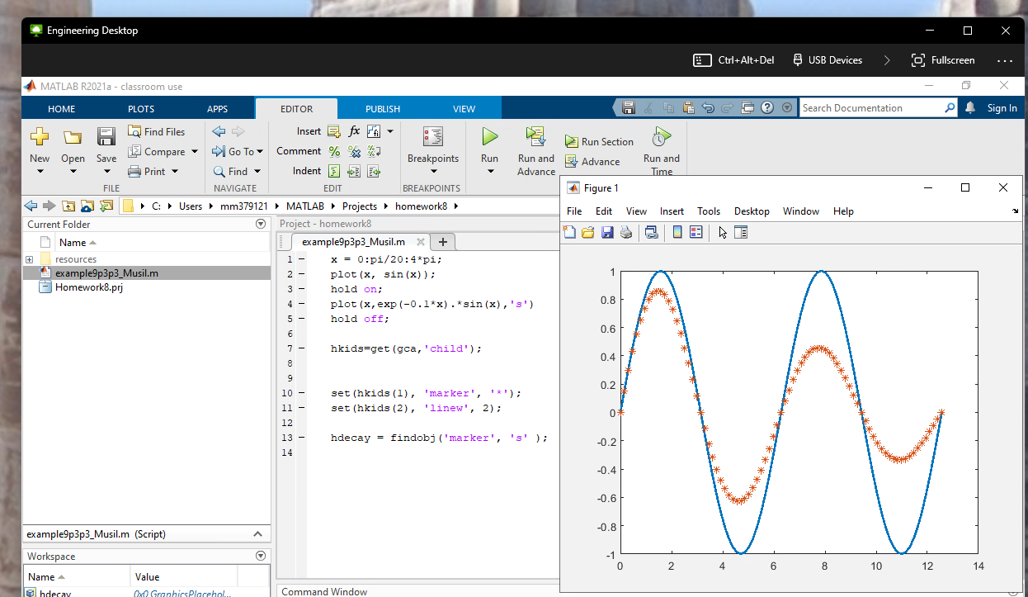

2. Create an m-file, named “example9p7b_LastName.m”, that has all the MATLAB® statements listed in at the bottom of page 229 and the top of page 230 in section 9.7 of the textbook. However, modify it by implementing the “prism” colormap (which, incidentally, should achieve a Dr. Suess look!) and set the position of the light to azimuth = 45 deg and elevation = 30 deg.

